Effective Stakeholder Collaboration on Complex Projects

A unique program for Project Managers and Collaborators

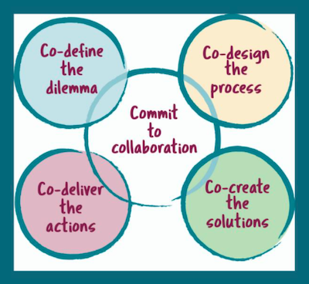

“I thoroughly enjoyed this training. Stuart is an exceptional collaborator with a real knack for teaching. The collaboration system guided us through the collaborative framework and tools we could apply for each situation. I would recommend the course to anyone working with others.”

Course participant 2023

It’s time to end the talkfest and get collaborating with purpose, clarity and confidence

- Are you tired of the silos getting in the way of problem solving?
- Are your stakeholders generating more heat than light, with less trust?
- Are vested interests and hidden agendas making progress hard?
- Are you feeling stuck and unsure what to do next to get progress?

Twyfords’ unique structured approach to collaboration gives you:

- Proven process steps to build shared direction and commitment across the silos and stakeholders;
- Powerful tools to build trust among all stakeholders, to get working positively.
- Steps to move people from vested interests and hidden agendas to shared direction and constructive conversations.
- A proven pathway and collaboration guide to get you moving again.

Designed to get you learning and collaborating
- delivered live online over six 90-minute sessions
- facilitated by collaboration specialist and expert trainer, Stuart Waters
- key frameworks and tools shared in each session.
Sessions are delivered weekly over six weeks, giving learners time to apply and integrate new concepts as you go. Throughout the program, your facilitator will be available for one-on-one advice and guidance.

Why learn with Twyfords?

For 30 years Twyfords has been making collaboration more effective, distilling that experience into our Unique Collaboration System, incorporating the Power of Co pathway and the Collaborative Project Guide. The system shows you how to collaborate effectively and gives you the processes and tools to get working.

Do collaboration properly with The Power of Co system.

This popular program will get you collaborating effectively. Learn how to:
- use the collaboration system to guide your collaboration
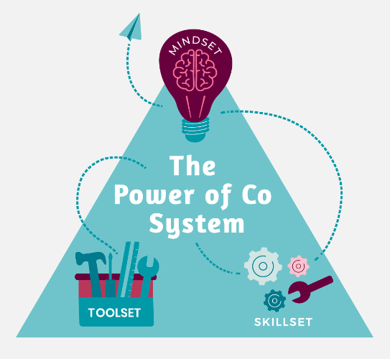
- use the most important frameworks from the field of collaboration to get great outcomes together
- apply key collaboration tools to efficiently achieve your key goals
- encourage positive relationships and effective communication to turbocharge your collaboration
- apply a rigorous approach to working with stakeholders with consistency on all your collaborative projects.

Take your collaboration and co-design to another level

Your Investment
$450 + GST per person

Book Now

“I can’t recommend the course highly enough. Very helpful in my current work, and always something new to chew over outside of the discussions.”

Course participant 2022

For more information email: Stuart waters: stuart@twyfords.com.au
Phone Stuart Waters: 0408 112 396
www.twyfords.com.au

